**---DESIGN THINKING NOTES**

* **Emphathy:  
  shadowing**
* **Questions answer**
* **Fly on the wall**

**---3 methords**

* **Persona mapping**
* **Emphathy mapping (find users and map it)**
* **Journey mapping**

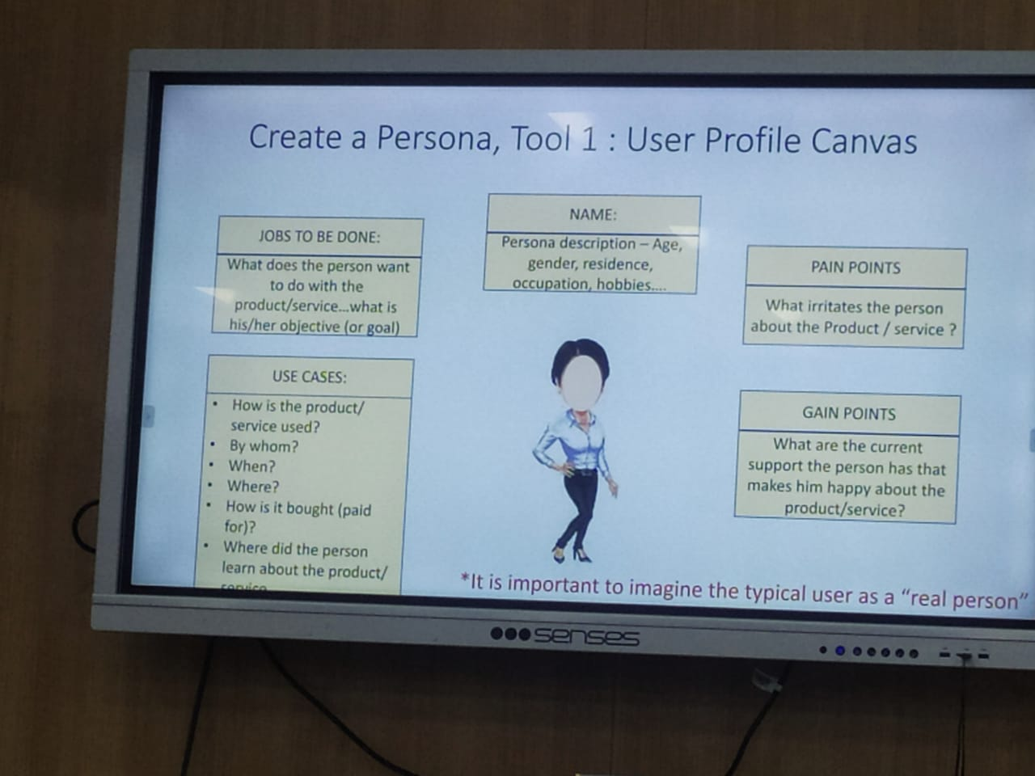

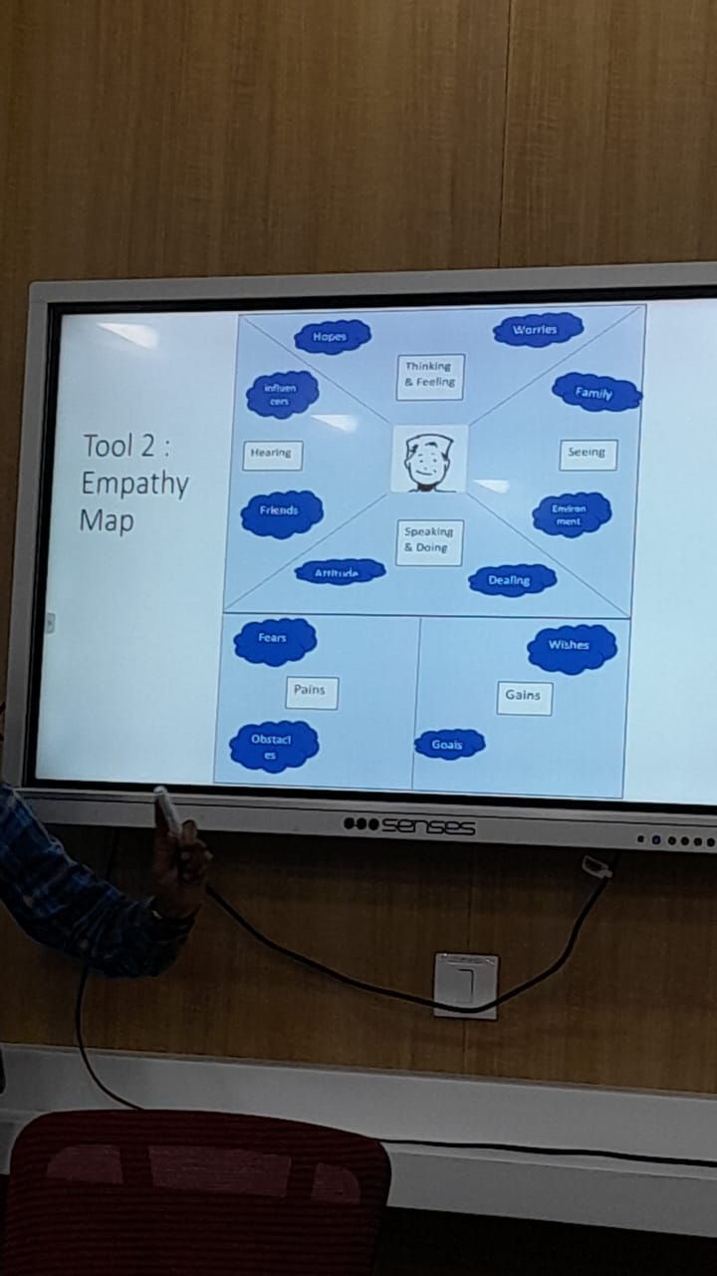

**3.JOURNEY MAPPING**

* **Before using product**
* **During using product**
* **After using the product**

**Note: do not give them solution ask them.**

**3.1 USER CAN DO 3 THINGS AT A TIME(related to feeling)**

* **Doing**
* **Thinking**
* **Saying**

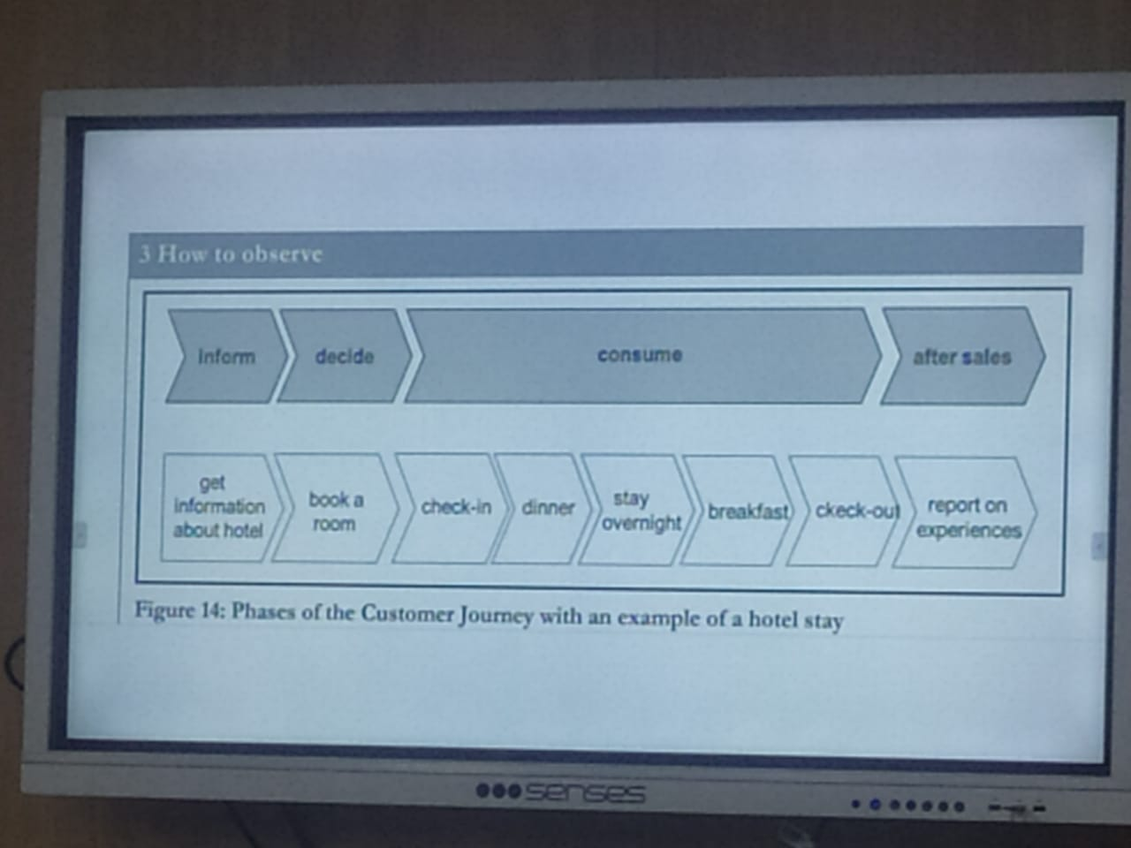

**Prototyping**

**Low fidelity**

**High fidelity**